Specifications
Nominal Voltage |  |  | 12 V
Capacity  (25℃) | 20HR(10.5V) |  | 5Ah
Capacity  (25℃) | 10HR(10.5V) |  | 4.7Ah
Capacity  (25℃) | 1HR(9.60V) |  | 3.2Ah
Dimension | Length |  | 90±1mm (3.54inch)
Dimension | Width |  | 70±1mm (2.76inch)
Dimension | Height |  | 101±1mm (3.98inch)
Dimension | Total Height |  | 107±1mm (4.21inch)
Approx. Weight |  |  | 1.6kg (3.53lbs)±5%
Terminal type |  |  | F1/F2
Internal resistance  (Fully charged, 25℃) |  |  | Approx. 26mΩ
Capacity affected by temperature (20HR) |  | 40℃ | 102%
 |  | 25℃ | 100%
 |  | 0℃ | 85%
 |  | -15℃ | 65%
Self-discharge  (25℃) |  | 3 month | Remaining Capacity: 91%
 |  | 6 month | Remaining Capacity: 82%
 |  | 12 month | Remaining Capacity: 65%
Nominal operating temperature |  |  | 25℃±3℃(77℉±5℉)
Operating temperature range |  | Discharge | -15℃～50℃(5℉～122℉)
 |  | Charge | -10℃～50℃(14℉～122℉)
 |  | Storage | -20℃～50℃(-4℉～122℉)
Float charging voltage(25℃) |  |  | 13.60 to 13.80V  Temperature compensation:  -18mV/℃
Cyclic charging voltage(25℃) |  |  | 14.50 to 15.00V  Temperature compensation:  -30mV/℃
Maximum charging current |  |  | 1.5A
Maximum discharge current |  |  | 75A(5 sec.)
Designed floating life(20℃) |  |  | 5 years

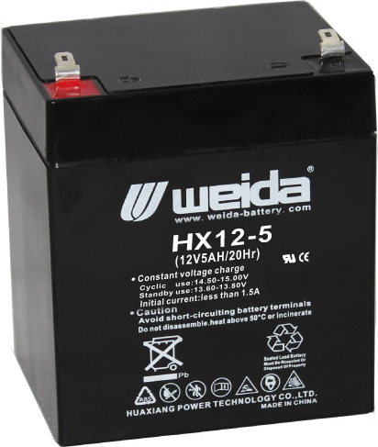
Dimensions
Terminal

Constant Current Discharge Characteristics (A, 25℃)
F.V/TIME | 5min | 10min | 15min | 30min | 60min | 2h | 3h | 4h | 5h | 10h | 20h
9.60V | 19.1 | 12.1 | 9.45 | 5.33 | 3.28 | 1.79 | 1.24 | 1.03 | 0.87 | 0.47 | 0.25
9.90V | 18.5 | 11.7 | 9.22 | 5.22 | 3.23 | 1.78 | 1.23 | 1.02 | 0.87 | 0.47 | 0.25
10.2V | 17.8 | 11.3 | 8.88 | 5.06 | 3.14 | 1.77 | 1.22 | 1.01 | 0.86 | 0.47 | 0.25
10.5V | 17.0 | 10.8 | 8.58 | 4.94 | 3.08 | 1.74 | 1.22 | 1.01 | 0.86 | 0.47 | 0.25
10.8V | 16.0 | 10.2 | 8.13 | 4.76 | 2.99 | 1.69 | 1.18 | 0.97 | 0.83 | 0.46 | 0.25
Constant Power Discharge Characteristics (Watt, 25℃)
F.V/TIME | 5min | 10min | 15min | 30min | 60min | 2h | 3h | 4h | 5h | 10h | 20h
9.60V | 213 | 136 | 108 | 61.0 | 37.9 | 21.0 | 14.7 | 12.2 | 10.4 | 5.68 | 3.05
9.90V | 207 | 132 | 105 | 59.8 | 37.4 | 20.8 | 14.6 | 12.1 | 10.4 | 5.66 | 3.03
10.2V | 198 | 127 | 101 | 58.0 | 36.4 | 20.7 | 14.5 | 12.1 | 10.3 | 5.63 | 3.02
10.5V | 190 | 121 | 97.8 | 56.6 | 35.7 | 20.3 | 14.4 | 12.0 | 10.2 | 5.60 | 3.00
10.8V | 179 | 115 | 92.6 | 54.5 | 34.6 | 19.8 | 14.0 | 11.6 | 9.90 | 5.49 | 2.94
Note: The above characteristics data can be obtained within three charge/discharge cycles.
Construction
Component | Positive plate | Negative plate | Container | Cover | Separator | Electrolyte | Safety valve | Terminal
Raw material | Lead dioxide | Lead | ABS | ABS | AGM | Sulfuric acid | Rubber | Copper

Discharge Characteristics(25℃)
The Relationship for Open Circuit Voltage and Residual Capacity (25℃)
Floating Life on Temperature
Effect of Temperature on Capacity
Charging Characteristics(25℃)
The Relationship for Charging Voltage and Temperature
Cycle Life on D.O.D(25℃)
Self-discharge Characteristics

www.huaxiangbattery.com

