Specifications
Nominal Voltage |  |  | 12 V
Capacity  (25℃) | 20HR(10.5V) |  | 24 Ah
Capacity  (25℃) | 10HR(10.5V) |  | 22.4Ah
Capacity  (25℃) | 1HR(9.60V) |  | 15.2Ah
Dimension | Length |  | 166±2mm (6.54inch)
Dimension | Width |  | 175±2mm (6.89inch)
Dimension | Height |  | 125±2mm (4.92inch)
Dimension | Total Height |  | 125±2mm (4.92inch)
Approx. Weight |  |  | 7.6kg (16.74lbs)±5%
Terminal type |  |  | F17/F18
Internal resistance  (Fully charged, 25℃) |  |  | Approx. 15mΩ
Capacity affected by temperature (20HR) |  | 40℃ | 102%
 |  | 25℃ | 100%
 |  | 0℃ | 85%
 |  | -15℃ | 65%
Self-discharge  (25℃) |  | 3 month | Remaining Capacity: 91%
 |  | 6 month | Remaining Capacity: 82%
 |  | 12 month | Remaining Capacity: 65%
Nominal operating temperature |  |  | 25℃±3℃(77℉±5℉)
Operating temperature range |  | Discharge | -15℃～50℃(5℉～122℉)
 |  | Charge | -10℃～50℃(14℉～122℉)
 |  | Storage | -20℃～50℃(-4℉～122℉)
Float charging voltage(25℃) |  |  | 13.60 to 13.80V  Temperature compensation:  -18mV/℃
Cyclic charging voltage(25℃) |  |  | 14.50 to 15.00V  Temperature compensation:  -30mV/℃
Maximum charging current |  |  | 7.2A
Maximum discharge current |  |  | 360A(5 sec.)
Designed floating life(20℃) |  |  | 5 years

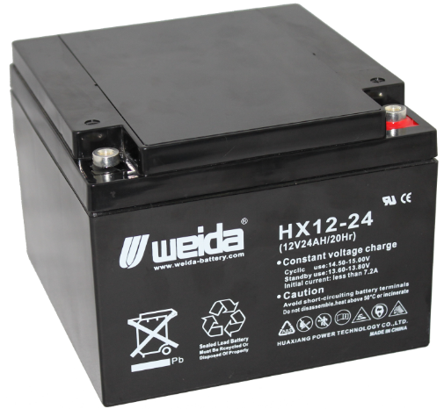
Dimensions
Terminal
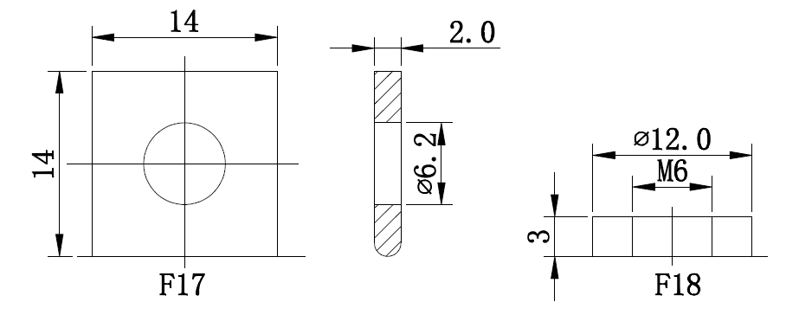

Constant Current Discharge Characteristics (A, 25℃)
F.V/TIME | 10min | 15min | 30min | 60min | 2h | 3h | 4h | 5h | 8h | 10h | 20h
9.60V | 56.3 | 44.0 | 24.8 | 15.2 | 8.60 | 5.95 | 4.92 | 4.19 | 2.72 | 2.27 | 1.22
9.90V | 54.6 | 42.9 | 24.3 | 15.0 | 8.55 | 5.91 | 4.89 | 4.16 | 2.70 | 2.26 | 1.21
10.2V | 52.4 | 41.4 | 23.6 | 14.6 | 8.47 | 5.87 | 4.86 | 4.13 | 2.68 | 2.25 | 1.21
10.5V | 50.1 | 40.0 | 23.0 | 14.3 | 8.34 | 5.83 | 4.82 | 4.10 | 2.66 | 2.24 | 1.20
10.8V | 47.3 | 37.8 | 22.1 | 13.9 | 8.13 | 5.66 | 4.68 | 3.98 | 2.58 | 2.19 | 1.18
Constant Power Discharge Characteristics (Watt, 25℃)
F.V/TIME | 10min | 15min | 30min | 60min | 2h | 3h | 4h | 5h | 8h | 10h | 20h
9.60V | 635 | 502 | 284 | 177 | 101 | 70.7 | 58.6 | 50.0 | 32.6 | 27.3 | 14.6
9.90V | 616 | 490 | 278 | 174 | 100 | 70.3 | 58.3 | 49.7 | 32.4 | 27.2 | 14.6
10.2V | 591 | 471 | 270 | 170 | 99.1 | 69.8 | 57.9 | 49.3 | 32.2 | 27.0 | 14.5
10.5V | 566 | 455 | 263 | 166 | 97.6 | 69.3 | 57.5 | 49.0 | 32.0 | 26.9 | 14.4
10.8V | 534 | 431 | 254 | 161 | 95.2 | 67.2 | 55.7 | 47.5 | 31.0 | 26.3 | 14.1
Note: The above characteristics data can be obtained within three charge/discharge cycles.
Construction
Component | Positive plate | Negative plate | Container | Cover | Separator | Electrolyte | Safety valve | Terminal
Raw material | Lead dioxide | Lead | ABS | ABS | AGM | Sulfuric acid | Rubber | Copper

Discharge Characteristics(25℃)
The Relationship for Open Circuit Voltage and Residual Capacity (25℃)
Floating Life on Temperature
Effect of Temperature on Capacity
Charging Characteristics(25℃)
The Relationship for Charging Voltage and Temperature
Cycle Life on D.O.D(25℃)
Self-discharge Characteristics

www.huaxiangbattery.com

