Specifications
Nominal Voltage |  | 12 V
Capacity(10HR, 25℃) |  | 7Ah
Dimension | Length | 151±2mm (5.94inch)
Dimension | Width | 87±2mm (3.43inch)
Dimension | Height | 95±2mm (3.74inch)
Approx. Weight |  | 2.5kg (5.51lbs)±5%
Operating temperature range |  | -20℃～50℃(-4℉～122℉)
Standard Charging method  (25℃) | Current | 0.7A
Standard Charging method  (25℃) | Time | 5~10h
Quickly Charging method  (25℃) | Current | 3.5A
Quickly Charging method  (25℃) | Time | 1h
Terminal material |  | Lead
Container Material |  | ABS
Discharge Characteristics(25℃)
Self-discharge characteristics
Dimensions
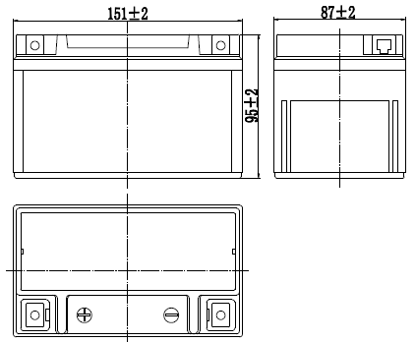

Terminal
