Specifications
Nominal Voltage |  | 12 V
Capacity(10HR, 25℃) |  | 6.5Ah
Dimension | Length | 137±2mm (5.39inch)
Dimension | Width | 66±2mm (2.60inch)
Dimension | Height | 102±2mm (4.02inch)
Approx. Weight |  | 2.15kg (4.74lbs)±5%
Operating temperature range |  | -20℃～50℃(-4℉～122℉)
Standard Charging method  (25℃) | Current | 0.65A
Standard Charging method  (25℃) | Time | 5~10h
Quickly Charging method  (25℃) | Current | 3.25A
Quickly Charging method  (25℃) | Time | 1h
Terminal material |  | Lead
Container Material |  | ABS
Discharge Characteristics(25℃)
Self-discharge characteristics
Dimensions
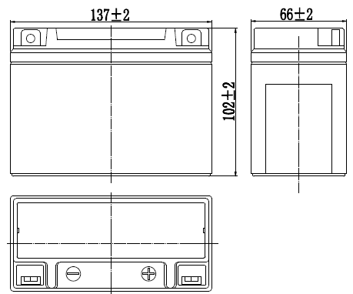

Terminal
