Specifications
Nominal Voltage |  |  | 12 V
Capacity  (25℃) | 20HR(10.5V) |  | 7.0Ah
Capacity  (25℃) | 10HR(10.5V) |  | 6.5Ah
Capacity  (25℃) | 1HR(9.60V) |  | 4.5Ah
Dimension | Length |  | 151±1.5mm (5.94inch)
Dimension | Width |  | 65±1mm (2.56inch)
Dimension | Height |  | 94±1mm (3.70inch)
Dimension | Total Height |  | 100±1mm (3.94inch)
Approx. Weight |  |  | 2.2kg (4.85lbs)±5%
Terminal type |  |  | F1/F2
Internal resistance  (Fully charged, 25℃) |  |  | Approx. 30mΩ
Capacity affected by temperature (20HR) |  | 40℃ | 102%
 |  | 25℃ | 100%
 |  | 0℃ | 85%
 |  | -15℃ | 65%
Self-discharge  (25℃) |  | 3 month | Remaining Capacity: 91%
 |  | 6 month | Remaining Capacity: 82%
 |  | 12 month | Remaining Capacity: 65%
Nominal operating temperature |  |  | 25℃±3℃(77℉±5℉)
Operating temperature range |  | Discharge | -15℃～50℃(5℉～122℉)
 |  | Charge | -10℃～50℃(14℉～122℉)
 |  | Storage | -20℃～50℃(-4℉～122℉)
Float charging voltage(25℃) |  |  | 13.60 to 13.80V  Temperature compensation:  -18mV/℃
Cyclic charging voltage(25℃) |  |  | 14.50 to 15.00V  Temperature compensation:  -30mV/℃
Maximum charging current |  |  | 2.1A
Maximum discharge current |  |  | 105A(5 sec.)
Designed floating life(20℃) |  |  | 5 years

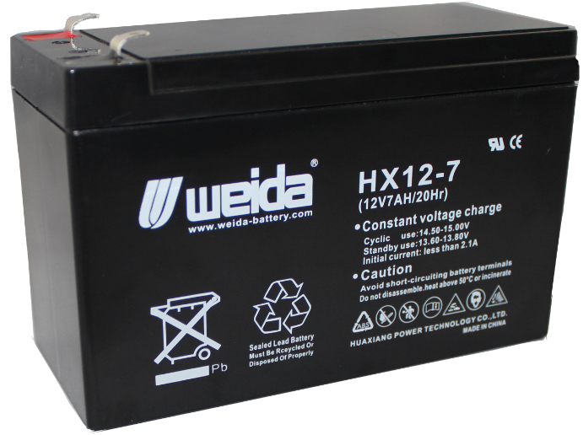
Dimensions
Terminal

Constant Current Discharge Characteristics (A, 25℃)
F.V/TIME | 5min | 10min | 15min | 30min | 60min | 2h | 3h | 4h | 5h | 10h | 20h
9.60V | 26.7 | 16.9 | 13.2 | 7.46 | 4.59 | 2.51 | 1.74 | 1.44 | 1.22 | 0.66 | 0.36
9.90V | 25.9 | 16.4 | 12.9 | 7.31 | 4.52 | 2.49 | 1.72 | 1.43 | 1.21 | 0.66 | 0.35
10.2V | 24.9 | 15.8 | 12.4 | 7.08 | 4.40 | 2.47 | 1.71 | 1.42 | 1.21 | 0.66 | 0.35
10.5V | 23.8 | 15.1 | 12.0 | 6.91 | 4.31 | 2.43 | 1.70 | 1.41 | 1.20 | 0.65 | 0.35
10.8V | 22.5 | 14.2 | 11.4 | 6.66 | 4.18 | 2.37 | 1.65 | 1.36 | 1.16 | 0.64 | 0.34
Constant Power Discharge Characteristics (Watt, 25℃)
F.V/TIME | 5min | 10min | 15min | 30min | 60min | 2h | 3h | 4h | 5h | 10h | 20h
9.60V | 298 | 191 | 151 | 85.4 | 53.1 | 29.3 | 20.6 | 17.1 | 14.6 | 7.95 | 4.26
9.90V | 289 | 185 | 147 | 83.7 | 52.3 | 29.2 | 20.5 | 17.0 | 14.5 | 7.92 | 4.25
10.2V | 278 | 178 | 142 | 81.2 | 51.0 | 28.9 | 20.3 | 16.9 | 14.4 | 7.88 | 4.23
10.5V | 266 | 170 | 137 | 79.2 | 50.0 | 28.5 | 20.2 | 16.8 | 14.3 | 7.84 | 4.20
10.8V | 251 | 161 | 130 | 76.3 | 48.4 | 27.8 | 19.6 | 16.3 | 13.9 | 7.68 | 4.12
Note: The above characteristics data can be obtained within three charge/discharge cycles.
Construction
Component | Positive plate | Negative plate | Container | Cover | Separator | Electrolyte | Safety valve | Terminal
Raw material | Lead dioxide | Lead | ABS | ABS | AGM | Sulfuric acid | Rubber | Copper

Discharge Characteristics(25℃)
The Relationship for Open Circuit Voltage and Residual Capacity (25℃)
Floating Life on Temperature
Effect of Temperature on Capacity
Charging Characteristics(25℃)
The Relationship for Charging Voltage and Temperature
Cycle Life on D.O.D(25℃)
Self-discharge Characteristics

www.huaxiangbattery.com

