Specifications
Nominal Voltage |  |  | 12 V
Capacity  (25℃) | 20HR(10.5V) |  | 9.0Ah
Capacity  (25℃) | 10HR(10.5V) |  | 8.4Ah
Capacity  (25℃) | 1HR(9.60V) |  | 5.9Ah
Dimension | Length |  | 151±1.5mm (5.94inch)
Dimension | Width |  | 65±1mm (2.56inch)
Dimension | Height |  | 94±1mm (3.70inch)
Dimension | Total Height |  | 100±1mm (3.94inch)
Approx. Weight |  |  | 2.7kg (5.95lbs)±5%
Terminal type |  |  | F1/F2
Internal resistance  (Fully charged, 25℃) |  |  | Approx. 20mΩ
Capacity affected by temperature (20HR) |  | 40℃ | 102%
 |  | 25℃ | 100%
 |  | 0℃ | 85%
 |  | -15℃ | 65%
Self-discharge  (25℃) |  | 3 month | Remaining Capacity: 91%
 |  | 6 month | Remaining Capacity: 82%
 |  | 12 month | Remaining Capacity: 65%
Nominal operating temperature |  |  | 25℃±3℃(77℉±5℉)
Operating temperature range |  | Discharge | -15℃～50℃(5℉～122℉)
 |  | Charge | -10℃～50℃(14℉～122℉)
 |  | Storage | -20℃～50℃(-4℉～122℉)
Float charging voltage(25℃) |  |  | 13.60 to 13.80V  Temperature compensation:  -18mV/℃
Cyclic charging voltage(25℃) |  |  | 14.50 to 15.00V  Temperature compensation:  -30mV/℃
Maximum charging current |  |  | 2.7A
Maximum discharge current |  |  | 135A(5 sec.)
Designed floating life(20℃) |  |  | 5 years

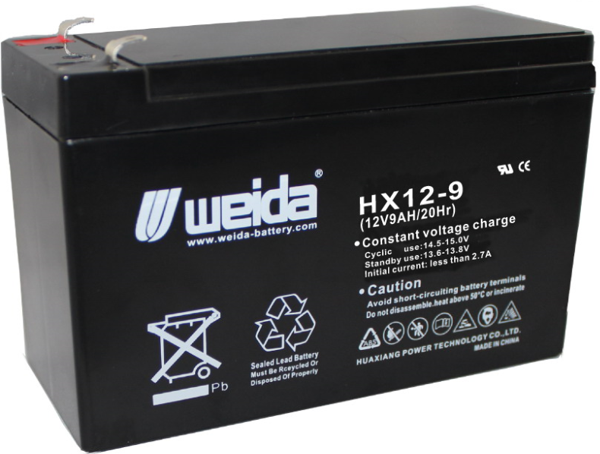
Dimensions
Terminal

Constant Current Discharge Characteristics (A, 25℃)
F.V/TIME | 5min | 10min | 15min | 30min | 60min | 2h | 3h | 4h | 5h | 10h | 20h
9.60V | 34.4 | 21.8 | 17.0 | 9.59 | 5.90 | 3.22 | 2.23 | 1.85 | 1.57 | 0.85 | 0.46
9.90V | 33.3 | 21.1 | 16.6 | 9.39 | 5.81 | 3.21 | 2.22 | 1.83 | 1.56 | 0.85 | 0.45
10.2V | 32.0 | 20.3 | 16.0 | 9.11 | 5.66 | 3.18 | 2.20 | 1.82 | 1.55 | 0.84 | 0.45
10.5V | 30.6 | 19.4 | 15.4 | 8.89 | 5.55 | 3.13 | 2.19 | 1.81 | 1.54 | 0.84 | 0.45
10.8V | 28.9 | 18.3 | 14.6 | 8.56 | 5.38 | 3.05 | 2.12 | 1.75 | 1.49 | 0.82 | 0.44
Constant Power Discharge Characteristics (Watt, 25℃)
F.V/TIME | 5min | 10min | 15min | 30min | 60min | 2h | 3h | 4h | 5h | 10h | 20h
9.60V | 384 | 246 | 194 | 110 | 68.3 | 37.7 | 26.5 | 22.0 | 18.7 | 10.2 | 5.48
9.90V | 372 | 238 | 189 | 108 | 67.2 | 37.5 | 26.3 | 21.8 | 18.6 | 10.2 | 5.46
10.2V | 357 | 228 | 182 | 104 | 65.5 | 37.2 | 26.2 | 21.7 | 18.5 | 10.1 | 5.43
10.5V | 341 | 219 | 176 | 102 | 64.2 | 36.6 | 26.0 | 21.5 | 18.4 | 10.1 | 5.40
10.8V | 322 | 206 | 167 | 98.1 | 62.3 | 35.7 | 25.2 | 20.9 | 17.8 | 9.87 | 5.29
Note: The above characteristics data can be obtained within three charge/discharge cycles.
Construction
Component | Positive plate | Negative plate | Container | Cover | Separator | Electrolyte | Safety valve | Terminal
Raw material | Lead dioxide | Lead | ABS | ABS | AGM | Sulfuric acid | Rubber | Copper

Discharge Characteristics(25℃)
The Relationship for Open Circuit Voltage and Residual Capacity (25℃)
Floating Life on Temperature
Effect of Temperature on Capacity
Charging Characteristics(25℃)
The Relationship for Charging Voltage and Temperature
Cycle Life on D.O.D(25℃)
Self-discharge Characteristics

www.huaxiangbattery.com

